How Do You
Learn Best?

Directions:
- Go to platform.majorclarity.com

- Enter your student email address

- Scroll down & click “Continue with Google”

- This will take you to your Wake ID Portal & back to Major Clarity
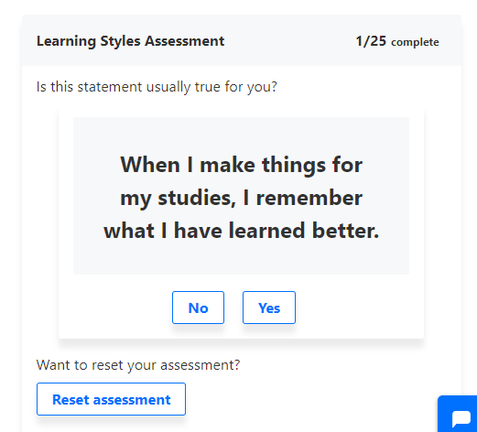

- Click on Edit your Profile
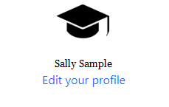

- Scroll down and find Learning Styles Assessment on
the bottom right of the screen. Begin to answer the
25 questions.

- What learning style got the highest percentage for you?

____________________________________________

- Check to see how accurate you think the survey was on
determining what kind of learner you are.
Click on What is this under your top learning style.

- How can this information help you as a student?

_____________________________________________

_____________________________________________

- List some ways that your learning style could affect your future career:

_______________________________________________________________________________________

