Creating a CFNC Account
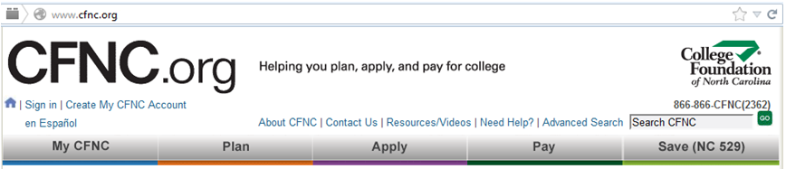
- Go to www.cfnc.org

- Click on Create My CFNC Account

- Beside High School Student Select Go
- Complete the Date of Birth section

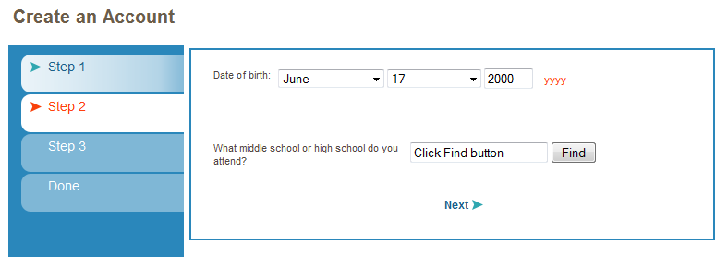
- To select our high school you MUST CLICK THE FIND BUTTON. Choose Heritage from dropdown box, then select

- (1 & 2) Type in your: First and Last Name.
(3) Scroll down to choose: Year of HS Graduation (20___).
(4 &5) Type in your: E-mail address (that you check most often).

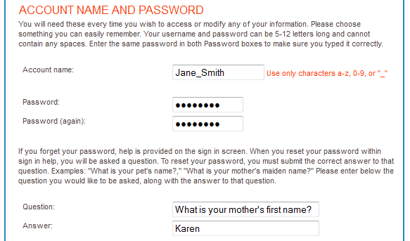
- CFNC will assign an Account Name to you.
(1 & 2) Type in your Password (in both places).
(3 & 4) Choose a Question & Answer
(in case you forget your password).

Type in your Permanent address:
(1, 2, 3, & 4) Street, City, State, and Zip Code
For Mailing address: (5) Check the Box: Same as Above
(6) Gender: Scroll down & choose: Male OR Female

