Creating your High School 4-Year Plan

Graduating from high school into a successful future takes years of exploration
& preparation. By learning about various careers and the educational background
and training required for each, you can dream about your future and take the steps
necessary to make those dreams come true.

Creating a 4-year plan will give you a guide towards the road to success!

Step 1: Course Planning
- Go to platform.majorclarity.com & enter your student email address

- Select Continue with Google and use your Wake County Google Account:

- Choose Academic Planning from the dashboard

Remember that this section can be updated! This section will help you and your counselor when completing your registration each year. All the components that are entered today can be updated at any time.
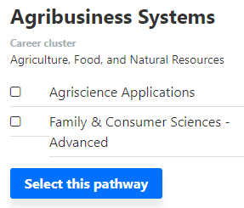

- Choose a Career Pathway based on your previous career research

- You will now be able to see what courses you have already completed and select classes that you would like to take in the future.

- Click on the + sign to expand the section and add the course that you plan to register to take.
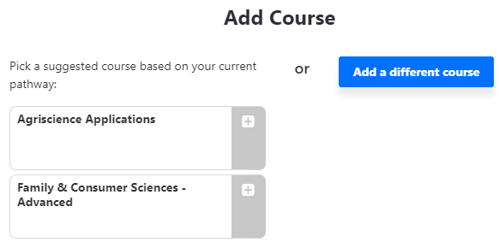
- You can pick a course based on
your current chosen pathway

OR

- You can add a different course

- Continue step 6 until you have courses in each section of your course plan. Remember that you can change these at any time if your interests change. This DOES NOT register you to enroll in these classes.

Step 2: Work-based learning

What kind of work- based learning activities would you like to participate in? (check any that apply)
Job Shadowing
Internship
Service Learning
Informational Interviews
Apprenticeship
Part-Time Employment

What clubs and organizations do you want to join? (list here, consider ones that align with your chosen pathway)

Step 3: Post-Secondary Plans
- Choose Postsecondary exploration

- Use the filters to narrow
your results.

- Select the colleges that interest you

- Click on the star to save it as a
favorite

- Click on the comparison tool in the
Upper right corner to compare your
favorite colleges

Step 4: Career Plan
- Select My Career Plan

- Enter your Career Goals, Education Goals, and Clubs and Activities that you have completed.

- Click the save button to save any additions to your Career Plan.

Lastly, share this career map with your parents, counselors, and teachers so they can help guide you on your journey!

Mrs. Beaster, 1204 Media Center, https://hhscareerdevelopmentservices.weebly.com/@huskycareers

